**Please read the document "MeritsAndLimitations.pdf" for details on Merits and Limitations of Histogram Equalization and Matching**

* **Packages Required:**

1. PyQt5
2. Pillow or PIL
3. opencv-python
4. opencv-contrib-python os

* **Command Line Help:**

Run the below command to view the help/usage message displayed by the solution:

python lomographic-filter.py -h

or

python lomographic-filter.py --help

**Help Message:**

Below Help message should be displayed in the console:

**Please read the user instructions document "ReadMe.pdf" for more details**

* **Startup and HomePage:**

Run the below command open the image window as shown in the below screenshot:

**Command:**

python lomographic-filter.py <image-file-name>

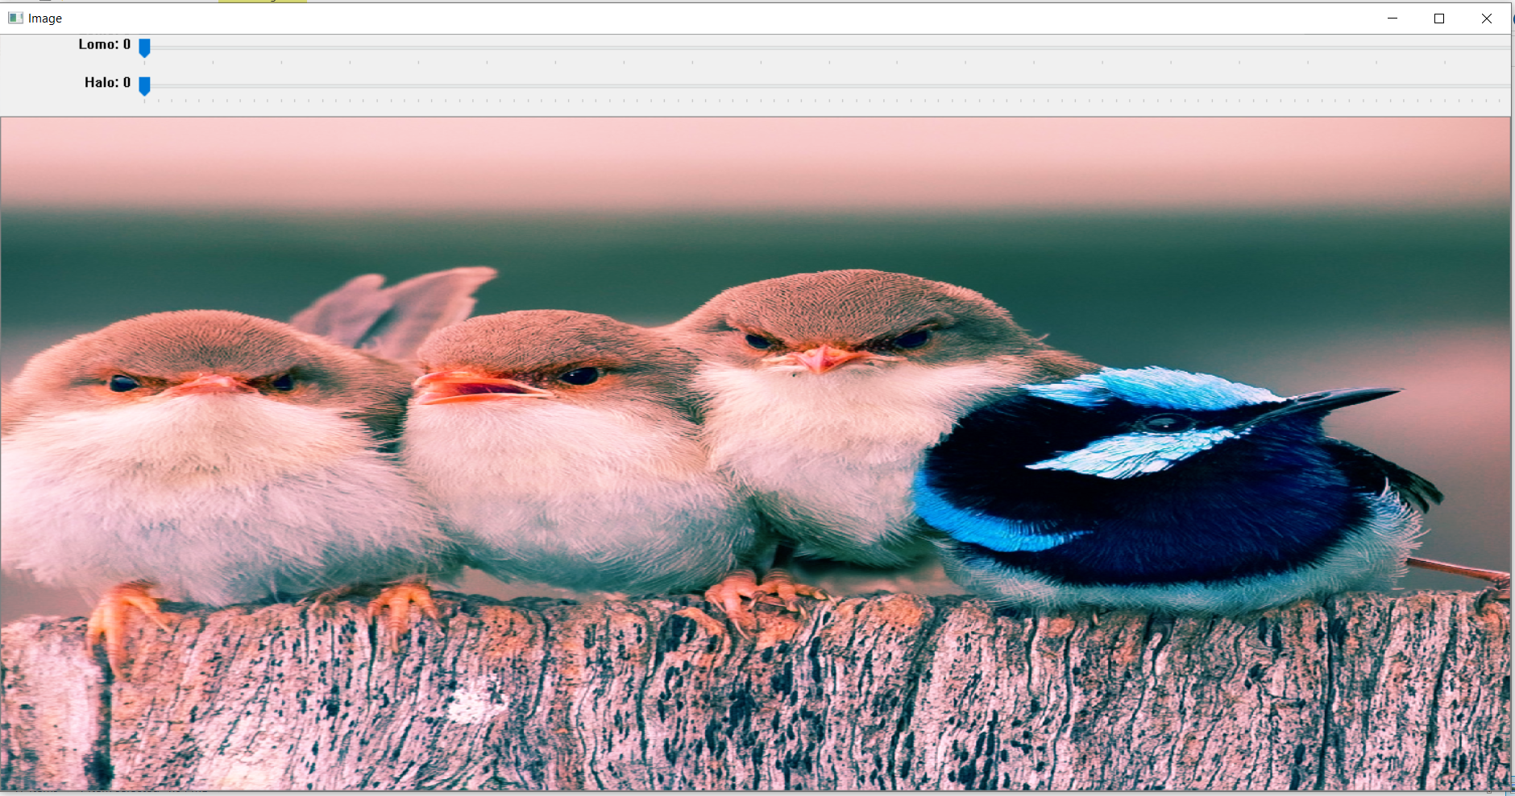

* **Save the image:**

Run the below command to save the copy of an image as shown in the below screenshot:

**Command:**

python lomographic-filter.py <image-file-name>

Type the character "s" from the keyboard to save the copy of an image.

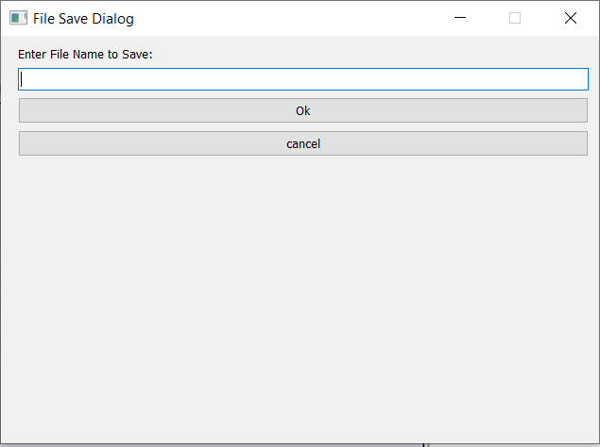

The copy of an image should be saved successfully.

* **Exit:**

Type the character "q" from the keyboard to exit from the image window.

**Note: Please press “q” to exit the program, closing the Image window will keep the program running in background and will crash python.**

* **Lomo filter:**
* Run the below command:  
   python lomographic-filter.py <image-file-name>
* The image window with lomo filter trackbar on the top should be displayed.
* Sliding lomo filter trackbar should increase or decrease the intensity of the image properly.

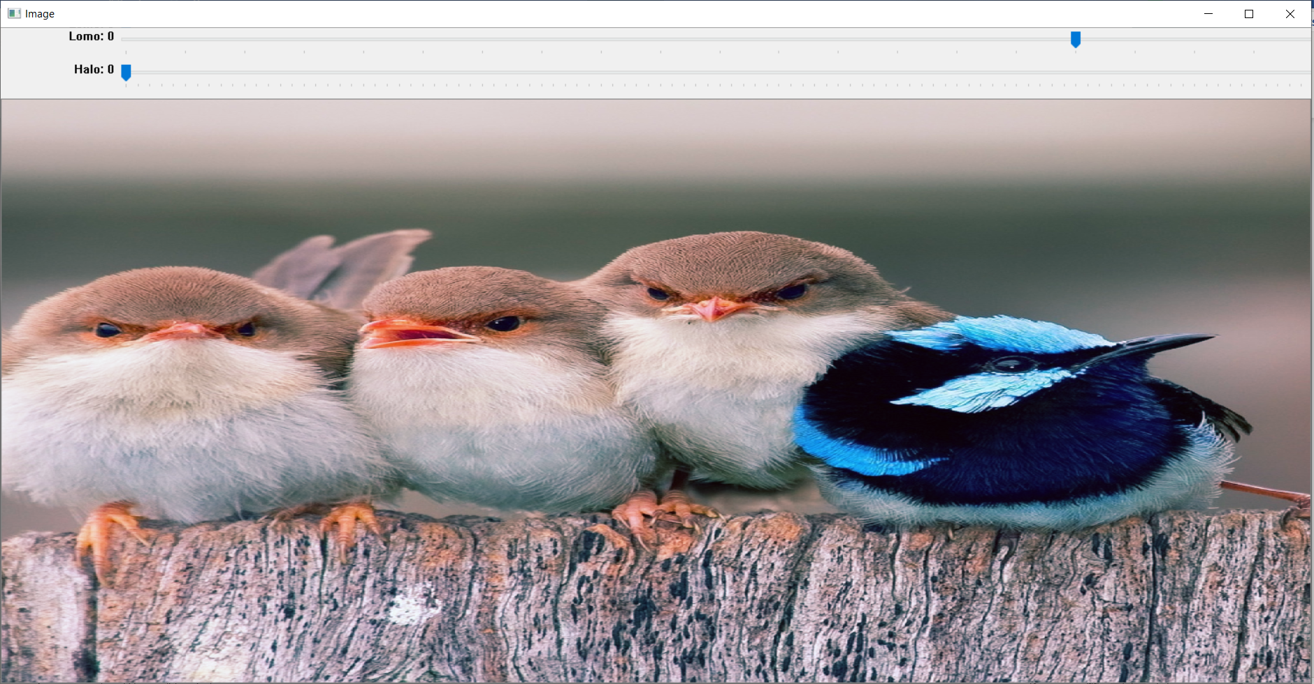

**Halo filter:**

* Run the below command:  
   python lomographic-filter.py <image-file-name>
* The image window with halo filter trackbar on the top should be displayed.
* The image with halo trackbar should be displayed with the lomo filter added.
* The halo effect should be adjusted every time the trackbar is moved.

